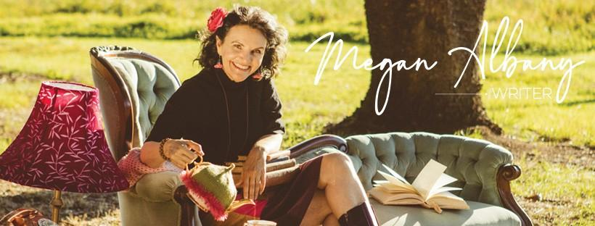

Megan Albany is a proud First Nations woman of Kalkadoon and European heritage who has worked as an editor, scriptwriter, songwriter/composer and journalist. Her debut novel, The Very Last List of Vivian Walker, released by Hachette Australia in February 2022, was one of only four works shortlisted for the 2020 Banjo Prize (Harper Collins), Highly Commended in the Australian Society of Authors 2020 Award Mentorship Program and has received glowing praise from national media. Due for release in the UK in August 2022, The Very Last List of Vivian Walker is a darkly funny and moving depiction of a woman who is dying but still has a list of jobs to do, such as cleaning the fridge, tidying the playroom, organising her own funeral and updating her husband and son's to-do lists.

'Remarkably talented...Albany's writing makes impending death seem hilarious.' Who Weekly
‘An abundance of humour, spirit and profundity.' Better Reading
'Compelling. Beautifully relatable.' Books + Publishing

Along with master musician Marc Mittag, Megan produced The Soundtrack - The Very Last List of Vivian Walker, due for release in August 2022. Mixed by ARIA award winner, Matt Fell, the album is a musical exploration of the nostalgia, humour, drudgery, outrageousness and grief that accompanies the journey of the dying. The first single, Sugar Comedown, was released in May 2022. Watch the video clip on YOUTUBE now.

‘Sugar Comedown is a colourful, sweet, summery music clip with a deliciously dark edge.... like the crazy journey that is life, this whole project from the book to the album offers an honest, real, rollercoaster of emotions.’ Amplify.com.au

AUTHOR BIO
Megan has written for publications including The Guardian (UK), Metro (Ireland), Irish Echo and The Koori Mail (Australia). She was both a writer and editor for leading Indigenous magazine, Deadly Vibe; the founding editor of InVibe magazine for Indigenous youth in custody; and was a researcher for Can It Hurt Less?, an SBS documentary into Australia’s juvenile justice system. For five years she was part of the scriptwriting team for the Deadly Awards (the Deadlys), the National Aboriginal and Torres Strait Islander Music, Sport, Arts and Community Awards, which screened on SBS TV and she was one of the founding concept developers for the NITV health programs, Living Strong and Move It Mob Style. Megan has a Master’s in Creative Writing and is currently penning her second book for Hachette Australia while completing her PHD in Creative Writing through QUT.

MUSIC BIO
Megan has released two previous albums as well as composing music for film and television. Her song Finding Myself reached number 26 in the Irish charts. She has performed at Dublin’s Fused Festival, the Heineken Music Festival and the Miller Genuine Music Festival. Her original composition Looking Good received national airplay and was featured on Rove Live and The Panel. Her songs Quiet Clear Pool and Sex With That, were licensed to the Neighbours TV series. Her composition, Song For Change was performed by Australian Idol Daniel Mifsud as part of the Marc Mittag and the Headhunters tour (Herbie Hancock’s band) and featured on the Sunrise Morning Show.

Megan lives with her thirteen year old son, her husband and their Moodle in the Northern Rivers of NSW. Connect with her on Instagram @meganalbanywriter, on Twitter @Megan_Albany or on Facebook @ meganalbanywriter, and learn more on her website, meganalbany.com, where you can find an original soundtrack Megan specially produced for The Very Last List of Vivian Walker.
www.meganalbany.com_megalbany@gmail.com

